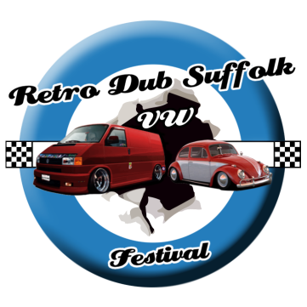
TRADERS
Retro Dub Suffolk VW Festival '24
20th – 22nd September 2024

Email: retrodubsuffolk@gmail.com
Mobile: 07384266797 (only operational over show weekend)

Dear Trader,

Please see the following information on trade booking for Retro Dub 2024:

We do not flood our show with trade, and pitches are sold on a first come first booked basis to reduce traders selling similar products.

When booking, please ensure all of your trade and camping facilities fit inside your pitch purchased.

Once booked, you will receive an email confirming your order. This must be shown at the gate in exchange for your wristbands.

Traders must be set up and ready to trade by gate opening times
(Friday: 12 noon, Saturday: 9am, Sunday: 9am).

Please also ensure a copy of your public liability insurance is sent to us ASAP after you have book.

Going on 11 years of 100% good feedback now, we are sure you will have a great time at Retro Dub Suffolk 2024.

Kindest Regards,

Retro Dub Crew.

Retro Dub Suffolk Festival Trade Booking Form 2024

PLEASE FILL OUT THE BELOW FORM AND SEND IT TO THE RETRO DUB EMAIL ADDRESS PRIOR TO BOOKING!
Email: retrodubsuffolk@gmail.com

Once we have confirmed via email that you are able to trade at the show, simply book your required pitch here!

Name(s):

Trading Name:

Goods Traded:

Address:

Email Address:

Each pitch includes 1 x Adult weekend pass, with all children under 16 are free. Additional staff/adult passes can be purchased at £20pp on the trading page on the website.

6m frontage x 6m depth: £75

9m frontage x 6m depth: £85

12m frontage x 6m depth: £95

Additional staff/adult pass: £20pp

Please provide any other additional information:

